Open-Ended Lab Report
Smart Lock Using ATMEGA
Course: Microprocessor Programming and Interfacing EL-3002
Instructor: Engr. Zohaib


Name | Roll Number | Dept & Section
Muzna Kamal | 23K-6002 | BSEE-A
Eshaal Ali | 23K-6075 | BSEE-A
Saman Rashid | 23K-6078 | BSEE-A

Table of Contents
Introduction: 2
Motivation: 2
Problem Statement & Targeted SGGs: 2
Targeted SDGs: 2
Application Interface: 2
Proposed Solution: 2
Block Diagram: 2
Literature Review: 3
Methodology: 3
Step 1: Hardware Design 3
Step 2: Software Development 4
Step 3: Integration and Simulation 4
Code: 5
Costing: 9
Results: 9
Simulation: 9
Hardware Implementation: 10
Discussion: 11
Conclusion & Future Recommendations: 11
Conclusion: 11
Future Enhancement: 11

Introduction:

Motivation:
With increasing security concerns in homes, offices, and laboratories, traditional mechanical locks are no longer sufficient due to risks of key duplication and physical wear. Embedded-system-based electronic locks provide better security, flexibility, and user control. This project is motivated by the need to design a low-cost, reliable, and easy-to-implement digital door locking system using a keypad, LCD, and servo motor controlled by an ATmega32 microcontroller.

Problem Statement & Targeted SGGs:
Unauthorized access to restricted areas leads to security breaches, theft, and safety risks. Many secure systems are either expensive or complex for small-scale deployment.

Targeted SDGs:

SDG 9 – Industry, Innovation, and Infrastructure:
Promotes innovation through microcontroller interfacing and design.

SDG 11 – Sustainable Cities and Communities:
Enhances safety and access control in residential and institutional environments.

Application Interface:
The system interfaces a 4×4 keypad for password input, a 16×2 LCD for user feedback, and a servo motor to physically lock/unlock the door, all controlled by the ATmega32 development board.

Proposed Solution:
The proposed solution uses a password-based authentication mechanism. When the correct password is entered via keypad, the microcontroller validates it and rotates a servo motor to unlock the door. Status messages are displayed on the LCD.

Block Diagram:
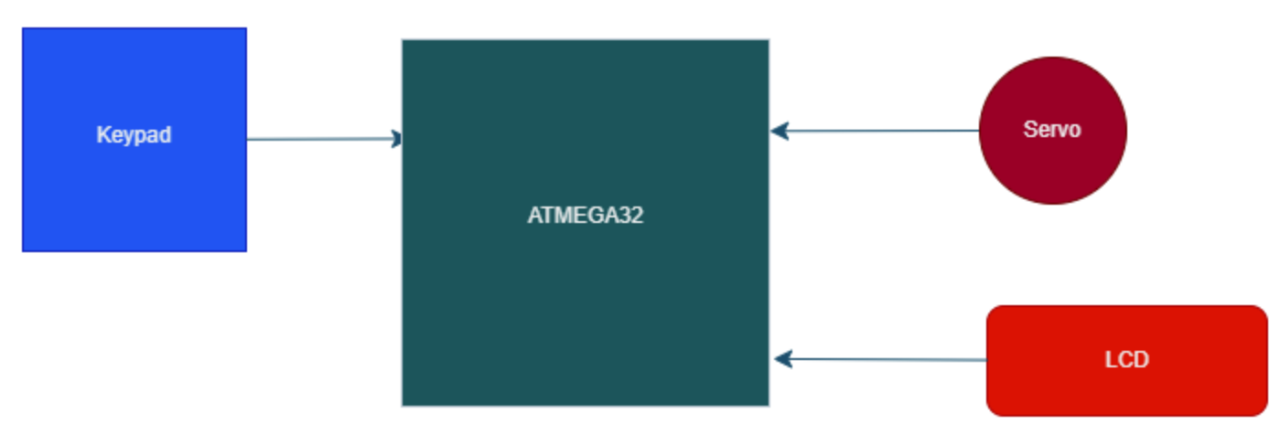
Figure 1: Architecture: Keypad is connected to PORTA, LCD is connected to PORT D, and Servo Motor to PORTC bit 0
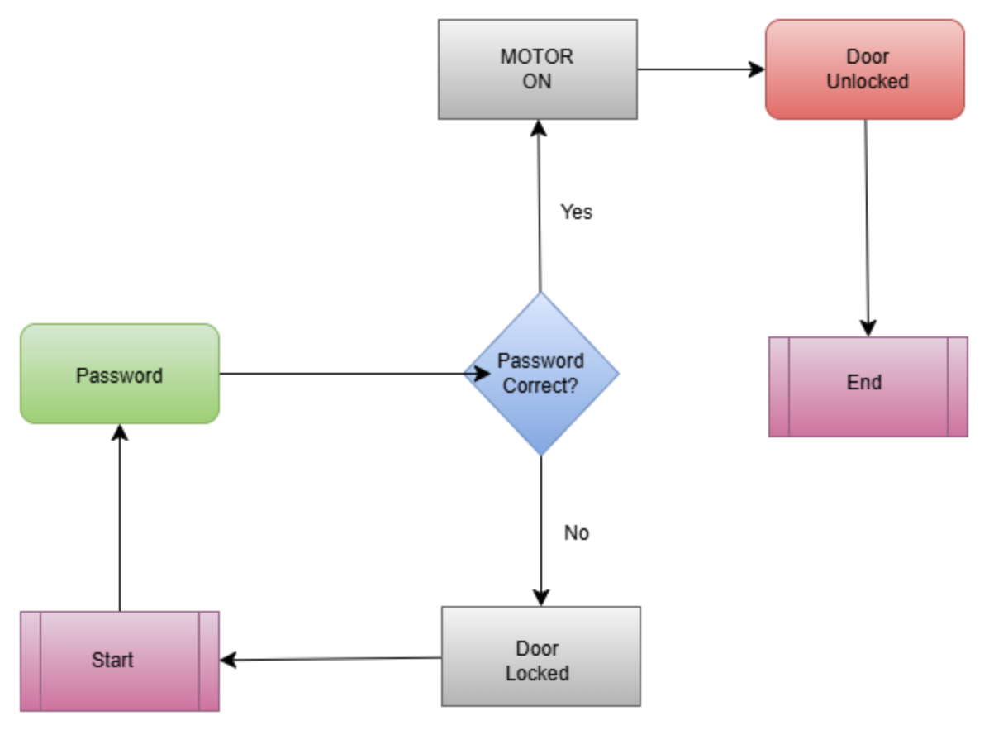
Figure 2: Program Logical Flow

Literature Review:
Several studies highlight the effectiveness of keypad and microcontroller-based locking systems:
- Password-based door lock systems using AVR microcontrollers.
- Embedded security systems using keypad and LCD interfaces.
- Servo motor-based access control mechanisms.
- Low-cost home automation and security solutions.
- Microcontroller-based electronic locks for smart homes.
- Comparison of biometric vs keypad security systems.
- Embedded systems for physical access control.
- Energy-efficient security systems using AVR.
- Design of digital locks using assembly language.
- Secure authentication techniques in embedded systems.

Methodology:

Step 1: Hardware Design
- ATmega32 microcontroller
- 4×4 matrix keypad connected to PORTA
- 16×2 LCD connected to PORTD (data) and PORTB (control)
- Servo motor connected to PORTC bit 0.
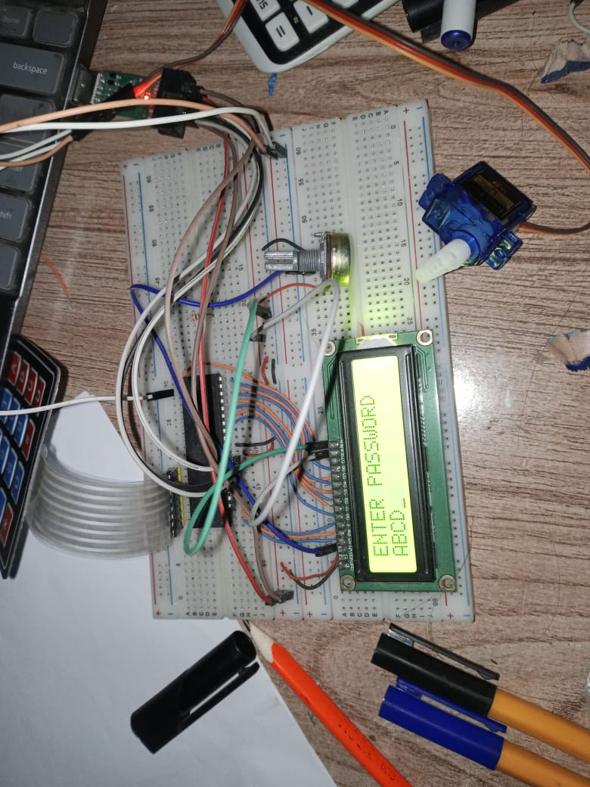
Figure 3: Hardware Design

Step 2: Software Development
- Assembly Language Programmed using m32def.inc
- LCD initialization and command routines
- Keypad scanning using row-column technique
- Password storage in SRAM
- Servo motor control using PWM-like delay pulses
; Store keypad input in SRAM
ST X, R16
INC R22
CPI R22, 3
BREQ CHECK_PASS
Each key press is stored sequentially in SRAM. Once three characters are entered, the password verification routine is triggered.

Step 3: Integration and Simulation
- Circuit designed and simulated in Proteus
- Verified correct password entry, LCD messages, and servo rotation
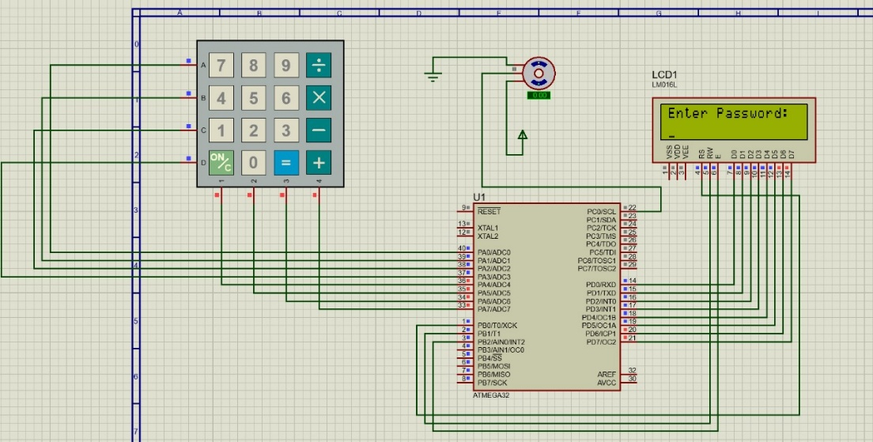

Code:
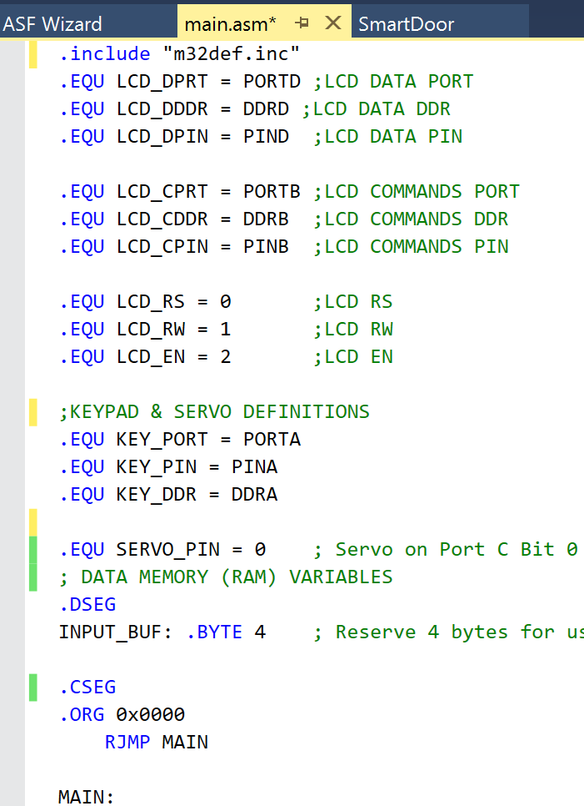
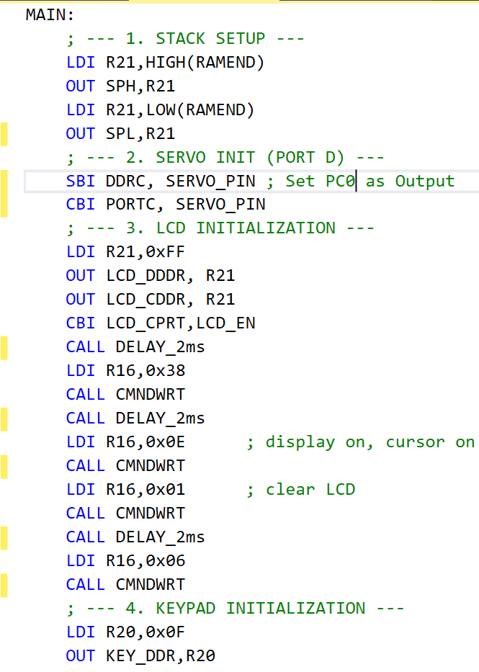
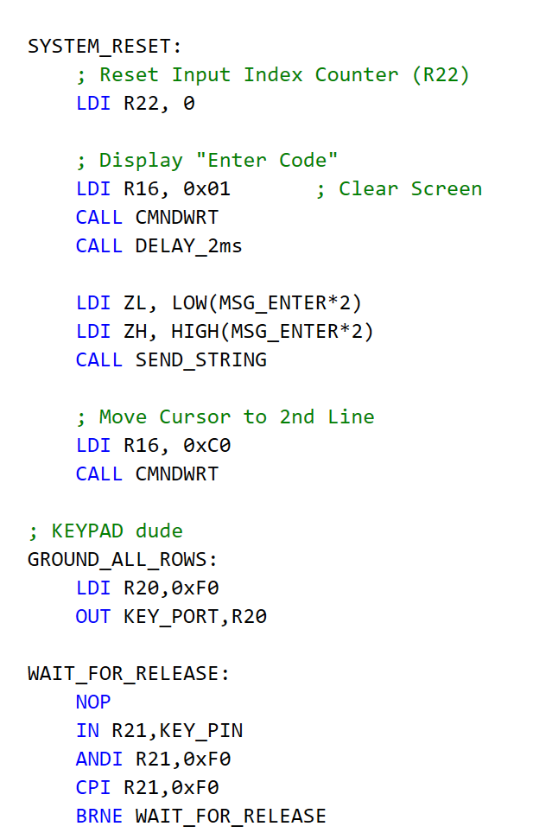
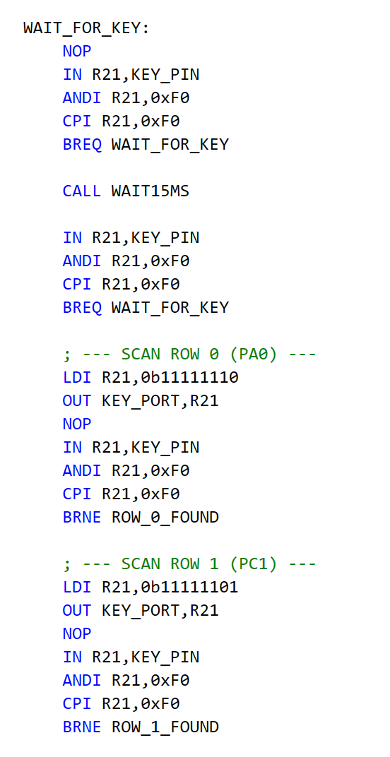
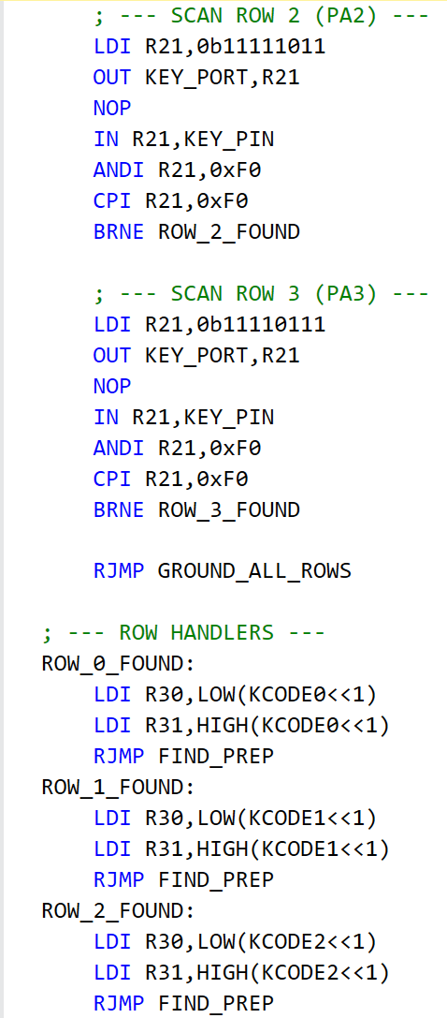
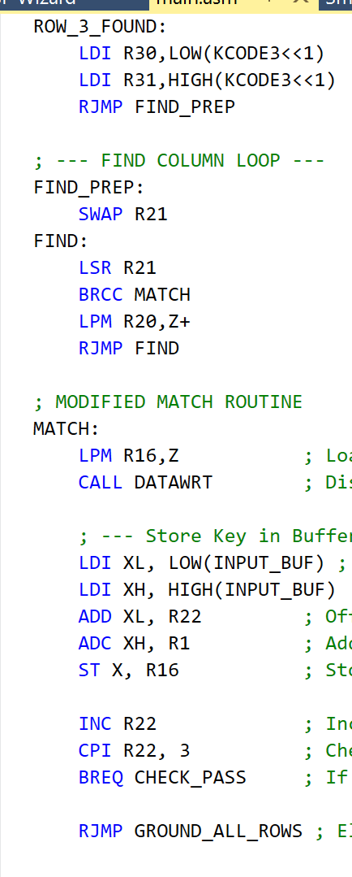
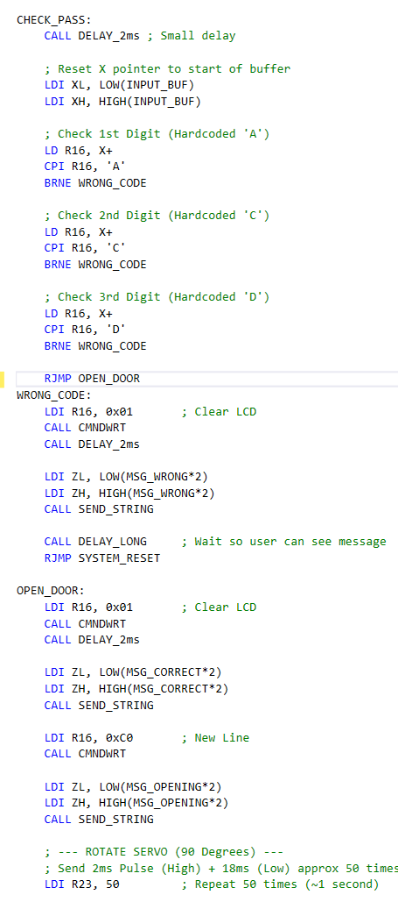
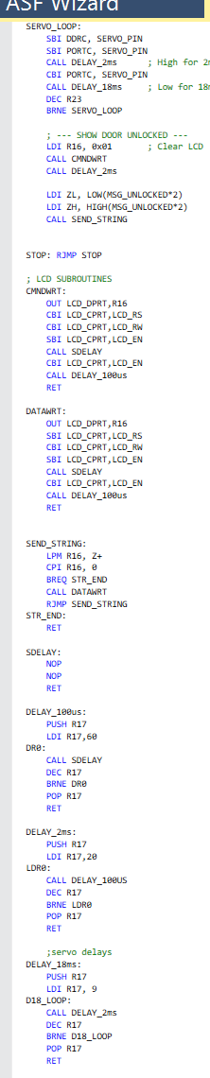
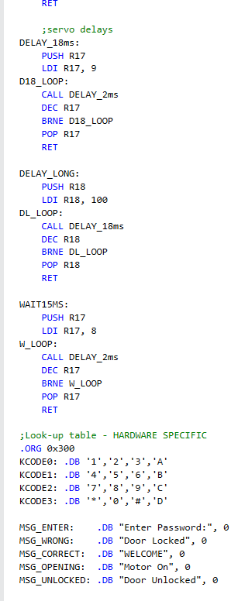

Costing:
Component | Specification | Quantity | Unit Cost (PKR) | Total Cost (PKR)
ATmega32 Microcontroller | 8-bit AVR MCU | 1 | 880 | 880
4×4 Matrix Keypad | Numeric Keypad | 1 | 150 | 150
Servo Motor | SG90 / Equivalent | 1 | 200 | 200
16×2 LCD | Alphanumeric Display | 1 | 300 | 300
Breadboard | Standard Size | 1 | 150 | 150
AVR Programmer | USBasp Programmer | 1 | 580 | 580
Total Project Cost |  |  |  | 2360 PKR

Results:

Simulation:
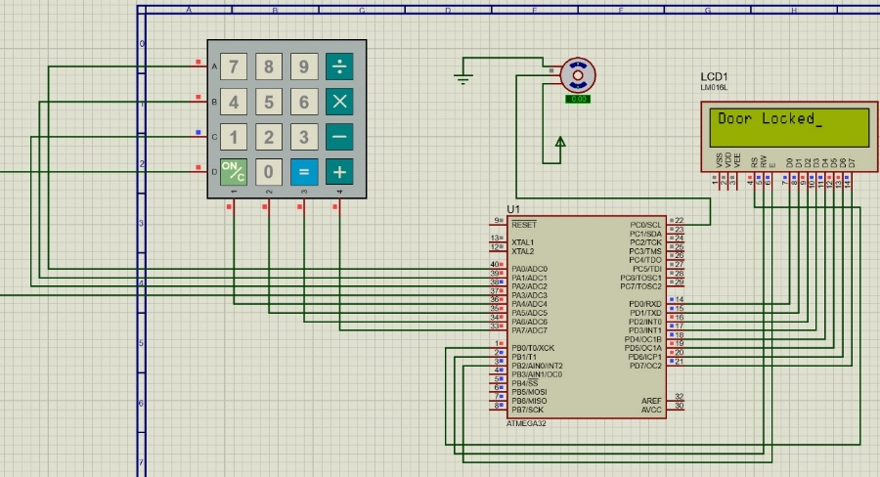
Figure 4: Incorrect Password, door locked, motor OFF
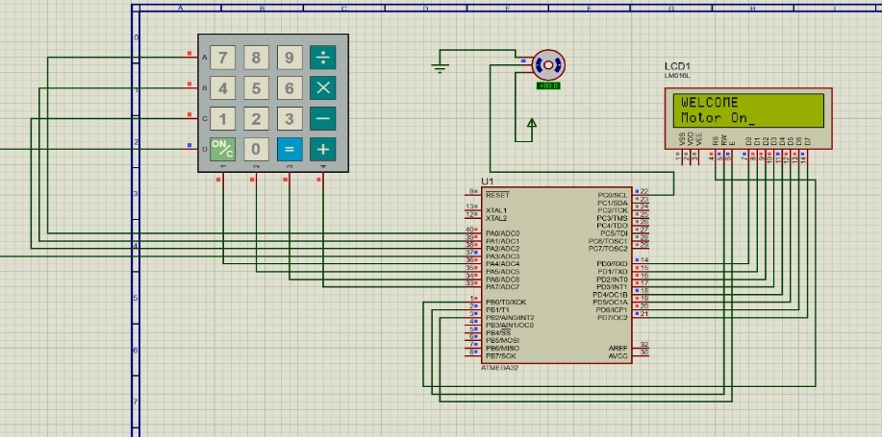
Figure 5: Correct Password, Motor ON

Hardware Implementation:
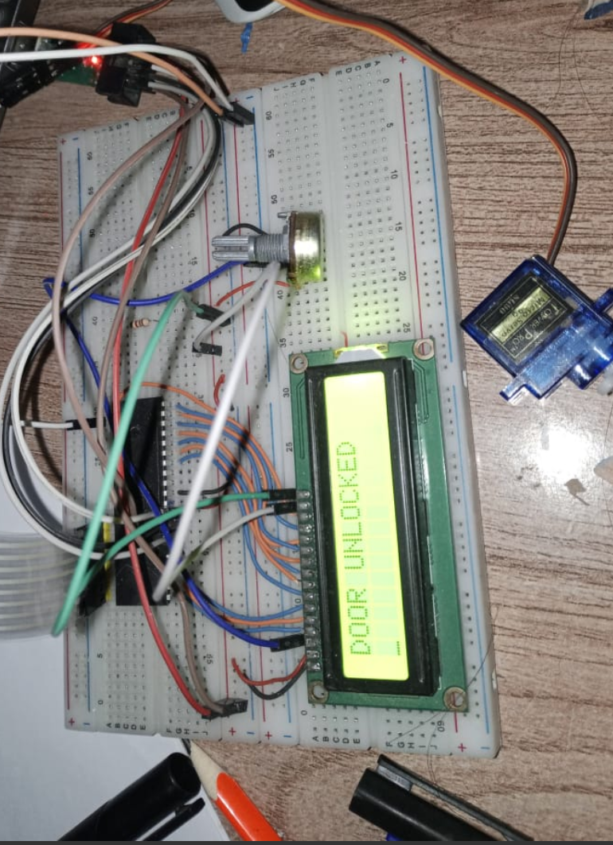
Figure 6: Password correct, door unlocked, Motor ON
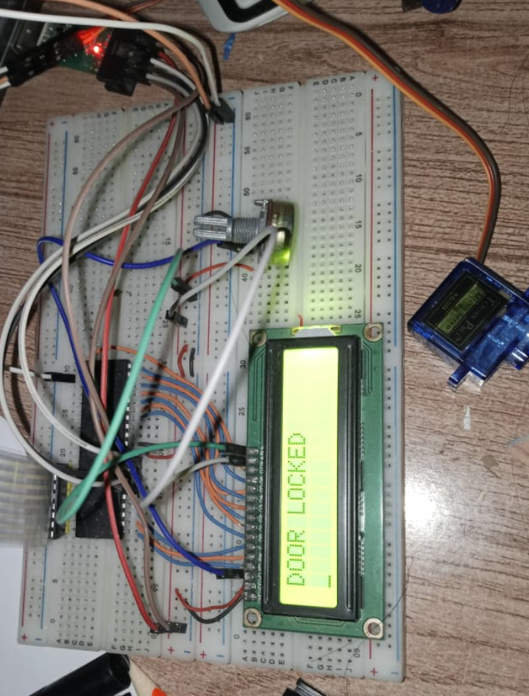
Figure 7: Password Incorrect, Door Locked, Motor OFF

Discussion:
The objective of secure access control is successfully achieved using a simple keypad-based authentication system. The system is reliable, fast, and easy to implement. Assembly-level programming provides full control over hardware timing, making the servo control precise. However, the system is limited to fixed passwords and does not include encryption or remote access.

Conclusion & Future Recommendations:

Conclusion:
A low-cost and efficient password-based door locking system was successfully designed and implemented using ATmega32. The system demonstrates practical application of embedded systems, interfacing techniques, and low-level programming.

Future Enhancement:
- Add EEPROM-based password change feature
- Integrate RFID or biometric authentication
- Add GSM/Wi-Fi for remote monitoring
- Implement buzzer/alarm on multiple wrong attempts.

